Fecal Flotation Egg Identification Guide

Veterinary Parasitology, Fifth Edition. Domenico Otranto and Richard Wall. © 2024 John Wiley & Sons Ltd. Published 2024 by John Wiley & Sons Ltd.

Part 1: Parasites and infection

(a) (b) (c) (d)
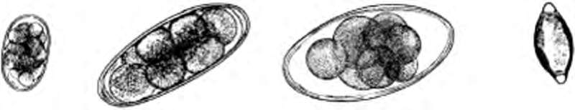
Strongyle egg
Nematodirus battus egg
Trichuris egg
Nematodirus
spathiger egg
Fig. 4.3 Nematode eggs.

150

100
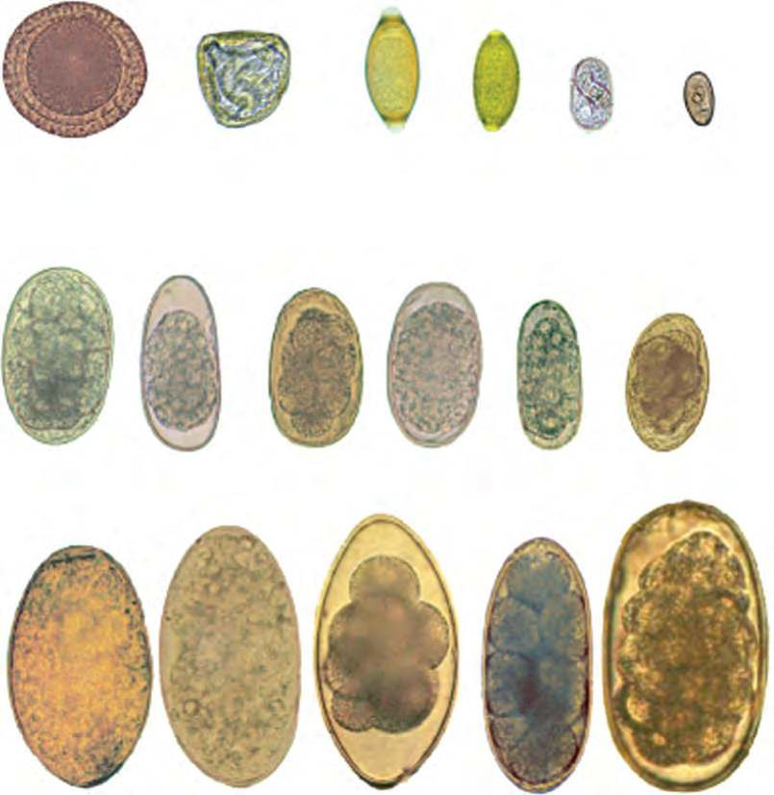
μm
Toxocara vitulorum
Moniezia spp.
Trichuris
spp.
Capillaria Strongyloides Dicrocoelium
spp.
papillosus
dendriticum
Chabertia ovina
Trichostrongylus Haemonchus
spp.
contortus
Ostertagia Cooperia Oesophagostomum
spp. spp. spp.

50

0

150

100
μm

50

0

150

100
μm

50

0
Fasciola hepatica

Paramphistomum
spp.

Nematodirus
spp.

Nematodirus battus

Marshallagia marshalli

Fig. 4.4 Helminth eggs from ruminants.

150

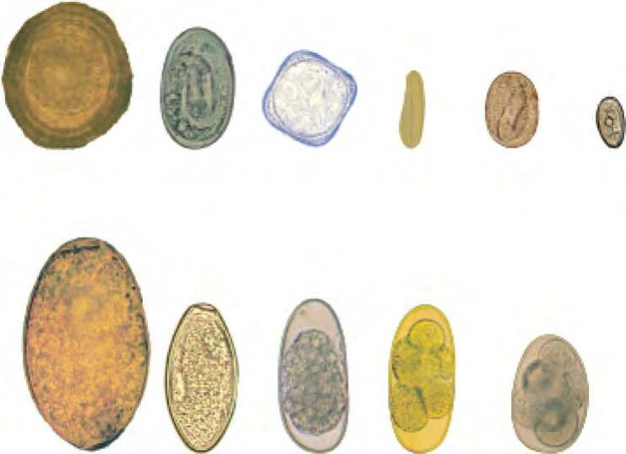
100
μm

50

0
Parascaris equorum

Dictyocaulus arnﬁeldi

Anoplocephala
spp.

Habronema
spp.

Strongyloides westeri

Dicrocoelium dendriticum

150

100
μm

50

0
Fasciola hepatica

Oxyuris equi

Trichostrongylus axei

Cyathostoma
spp.

Strongylus
spp.

Fig. 4.5 Helminth eggs from horses.

150

100
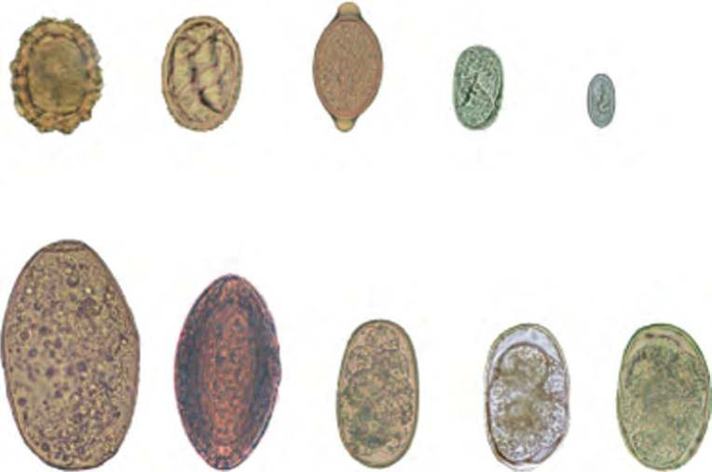
μm
Ascaris suum Metastrongylus
spp.
Trichuris suis
Strongyloides Physocephalus ransomi sexalatus

50

0

150

100
μm

50

0
Fasciolopsis buski
Fig. 4.6 Helminth eggs from pigs.

Macracanthorhynchus hirudinaceus

Hyostrongylus rubidus

Globocephalus urosubulatus

Oesophagostomum dentatum

328 Part 1: Parasites and infection

150

100
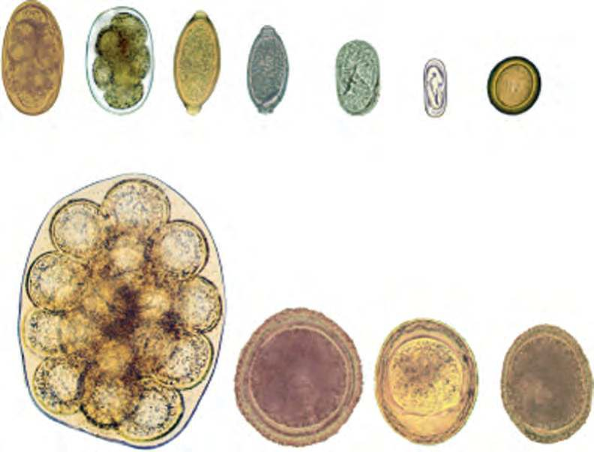
μm
Uncinaria Ancylostoma Trichuris stenosephala spp. spp.
Capillaria
spp.
Strongyloides Spirocerca
stercoralis
lupi
Taenia
spp.

50

0

150

100
μm

50

0
Dipylidium caninum

Toxocara canis

Toxascaris leonina

Toxocara mystax

Fig. 4.7 Helminth eggs from dogs and cats.

150

100
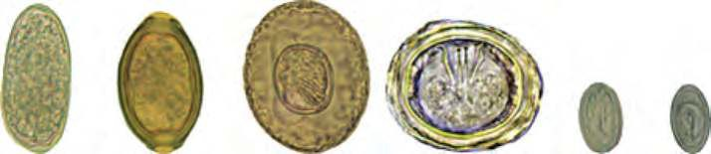
μm

50

0
Trichostrongylus tenuis

Capillaria spp. Raillietina
spp.

Choanotaenia
spp.

Echinuria
spp.

Terameres
spp.

150

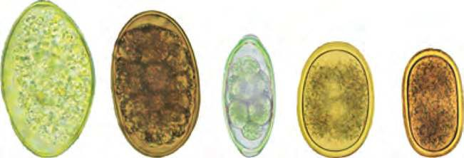
100
μm

50

0
Echinostoma
spp.

Amidostomum
spp.

Syngamus trachea

Ascaridia galli

Heterakis gallinarum

Fig. 4.8 Helminth eggs from poultry.

150

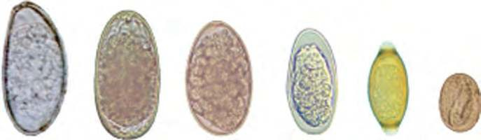
100
μm

50

0
Passalurus ambiguus

Graphidium strigosum

Trichostrongylus retortaeformis

Obeliscoides cuniculi

Trichuris leporis

Strongyloides papillosus

Fig. 4.9 Helminth eggs from rabbits.

